

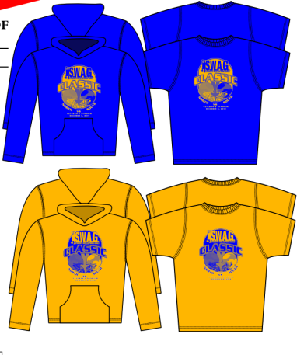

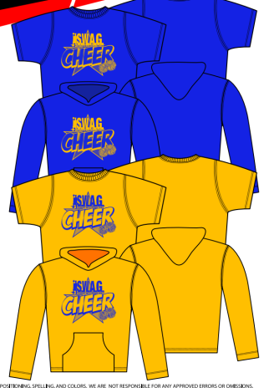 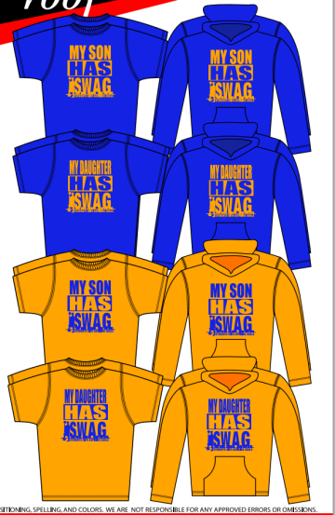

|  |  |  |  |  |  |  |
| --- | --- | --- | --- | --- | --- | --- |
| **Name** | **Design** | **Quantity** | **SIZE** | **T-Shirt or Hoodie** | **Cash or Check** | **Paid?** |
| DeVon | Classic | 1 | XL | Hoodie | Cash | Yes $25 |
|  |  |  |  |  |  |  |
|  |  |  |  |  |  |  |
|  |  |  |  |  |  |  |
|  |  |  |  |  |  |  |
|  |  |  |  |  |  |  |
|  |  |  |  |  |  |  |
|  |  |  |  |  |  |  |
|  |  |  |  |  |  |  |
|  |  |  |  |  |  |  |
|  |  |  |  |  |  |  |