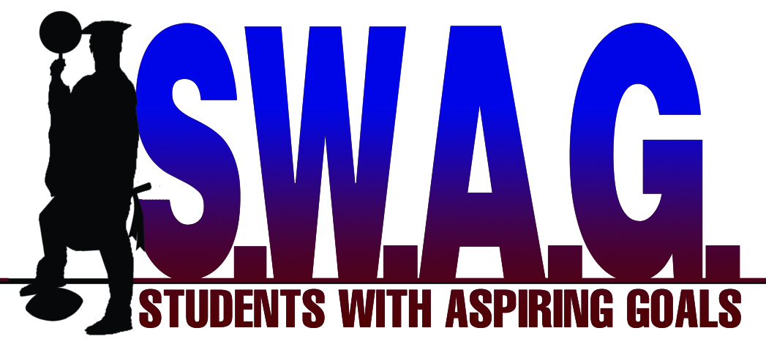
[11/17/2014]
Dear S.W.A.G Classic Parents/Participants:
First of all we would like to congratulate you on your selection to the 1st Annual “S.W.A.G Classic.” The “S.W.A.G Classic” is a game that will take Merced County’s most talented youth football players and have them compete on the same field. S.W.A.G’s mission is: To mentor and encourage student athletes in underprivileged communities advance to four year universities by preparing them for college entrance and enhancing their natural athletic gifts with competent training. In order for this event to be successful we need 100% participation from the participants and parents. Here is some important information in regards to the “S.W.A.G Classic.”
AAU Insurance
To be a participant of this game, you will need to purchase an AAU membership under Students With Aspiring Goals. Youth athlete memberships are $14.00 per athlete. Please go to www.aausports.org and click “Purchase a Membership.” You will use club code WW7A54. AAU members are covered with sports accident and limited liability insurance. For an additional $2, participants can purchase Extended Benefit membership which extends coverage when participating in non-AAU sanctioned events.
Practice
Practice for the game will start on Tuesday December 2, 2014. The practice for the North Team will be at Livingston HS from 530pm -730pm from Tues-Thurs. The practice for the South Team will be at Golden Valley from 530pm-730pm from Tues-Thurs. All teams will practice at Golden Valley HS on Friday December 5, 2014 (Time TBD). Please make sure you attend all practices during the week.

“S.W.A.G Classic T-Shirts”
We are asking that every participant take part in the selling of “S.W.A.G Classic” T-Shirts. For every $50.00 sold, you will receive one raffle ticket to win a Playstation 4 (valued at $400.00). The money for the shirts will be due on November 25, 2014. S.W.A.G staff will be at the office located at 450 W. 21st Street Suite F, Merced CA 95340 from 5pm-6pm. Shirts will be given out at practice on December 5.

Progress Reports
Every player and cheerleader will need to bring an up to date progress report to practice on Tuesday December 2, 2014. This progress report must be done not more than one week prior to December 2. This progress report must be handwritten (see attached form). AGAIN, THIS PROGRESS REPORT MUST BE HANDWRITTEN. If your progress report is not complete by start of practice on December 2, you will be given extra running (punishment). For every day that your progress report is late thereafter you will sit out a quarter of the game, per day. Let’s get this progress report in on time. Parents, please ensure your kid turns in the progress report in on time. We will be honoring student athletes with a 3.5 GPA or higher (from progress report) at the “S.W.A.G Classic.”

Game Day
The “S.W.A.G Classic” will take part on December 6, 2014 at Veteran’s Stadium (Golden Valley High School). The JV game will start at 11 am, and the Varsity game will start at 1 pm. You will be expected to show up to the game at least 1 hour before start time (warm up, weigh in). We will use the Cen Cal weight limit. The weight limit for JV is 140.9 and for Varsity is 184.9. The X-Man is unlimited weight. The X-Man must play on the line of scrimmage and play in between the Tackles. The X-Men will be designated with an X on their helmets.

Game Jerseys
The official game jerseys will be gold for the South Team and royal blue for the North Team. Participants are expected to wear their game jerseys to school on Friday December 5th. These jerseys will be returned at the end of the game on December 6th. You will have the option to purchase the jersey for $25.00 at Friday’s practice or after your game. You will pay a S.W.A.G representative if you choose this option.

Once again Students With Aspiring Goals will like to congratulate you on a successful season, and we look forward to working with you in the future. If you have any questions please feel free to contact Brett Nickelson at (209) 676-0104 or DeVon Hilliard at (209) 676-0335.

