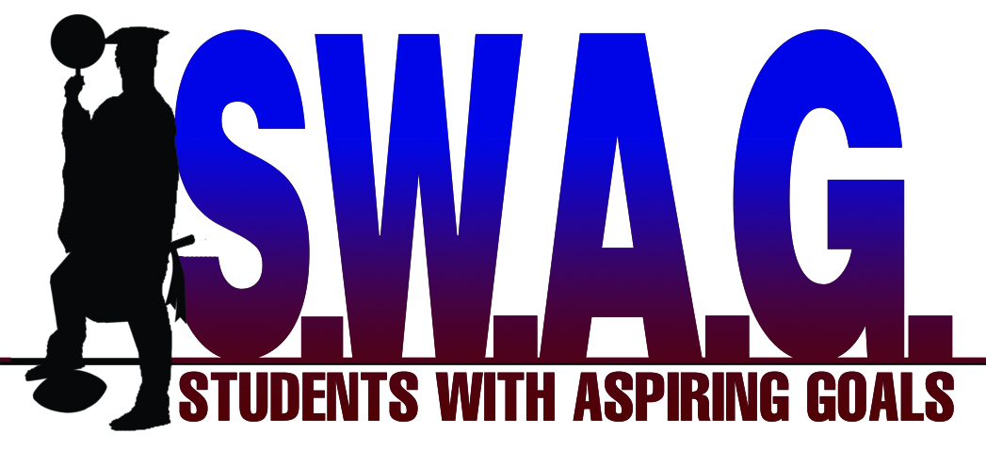
PROGRESS REPORT

Teachers, Students With Aspiring Goals (S.W.A.G) is a non-profit organization who serves Merced County. S.W.A.G’s mission is to prepare student athletes for college admission through academics, mentoring, and national exposure. Please fill out this progress report for our student athlete so we can identify any deficiencies. This report must be handwritten. If you have any questions feel free to contact S.W.A.G Founder/Director DeVon Hilliard at (209) 676-0335 or dhilliard.swag@gmail.com.

Course | Grade | Comments | Teacher/Signature

